TeleHealthcare

1. What is the relevant problem(s) or need?

- Reducing the cost of healthcare for both payers and patients, for patients with chronic diseases such as chronic heart failure, obesity, hypertension and diabetes.
- Providing continuous medical management & care at all times wherever you are.
- Improving the quality, simplicity and convenience of outpatient and in home health care solutions for the patient and health care service provider.
- Enabling Hospitals’ strategic focus to contain costs and increase service revenues by moving to a home based out patient monitoring and management service model.
- Enabling healthcare providers to deliver optimal treatment regimes (diagnosis, prescription, recovery and rehabilitation) based upon patients actual bodily information.

Background Information

Over the last few years healthcare costs have risen dramatically for patients and payers, healthcare insurance premiums rose 12% in 2003 and total costs are projected to reach 16% of GDP in 2004. Employers have estimated that a small percentage of their work force with chronic diseases incurs the majority of their health care costs (some figures from Motorola Wellness suggest 5% of employees account for 80% of all claims). To this end 37% of employers are offering incentives to employees who participate in disease management programs to manage their diseases within a disease management program e.g. Motorola pays $600/yr into HRA account to employees who conform to a paper based management process.
The graying of the population is a major factor-impacting healthcare in the US. In 2000 there were 3.3 workers for every retiree, a fifth of what it was in 1950 and it is predicted to shrink further to 1.6 workers per retiree by 2040, which will have a significant impact on the resource of the healthcare providers and their funding. The healthcare providers are further burdened by the an increasing shortage of healthcare professionals, doctors and nurses, the higher cost of care for chronic disease patients, and the focus of healthcare payers in using managed care and negotiated fees.
A number of trials have demonstrated the value of Telemedicine solutions; all of these are primarily targeted at the home market and have been performed by health service providers as a way of reducing their costs. For example Florida’s Veteran’s Hospital Administration – reduced hospital admissions by 76% and, emergency visits by 87% for chronic heart patient (CHF), while a pilot program in Ulm, Minnesota reduced the need for nurses to drive to remote patients, cutting the cost per visit by 50% and significantly reducing hospital visits and, admissions for CHF patients. Deployment of such an in home monitoring solution with video conferencing averages about $10,000 per patient.
Apart form demonstrating significant cost savings these trials also showed the Telemedicine improves the overall quality of life for the patient considerably.

- What is the business opportunity? (Qualitative: Motorola value, growth, market share, profitability)

The total U.S. healthcare expenditure for 2000 was $1.3 Trillion of which the Home Healthcare and Personal Healthcare markets were estimated to be about $220 billion.

Healthcare payers are demanding solutions to curb the rising costs. Disease Management companies have evolved over the last few years to meet the demand of corporate, managed care programs etc. They offer services directed at working with the segment of patients who have diseases that through management & education significant cost savings in the payment of health care costs can be achieved. Hospitals continue to look at ways of reducing their medical costs and resource needs, their strategy is to move more of the care to Outpatient services and further away from the confines of the hospital into the patient’s homes.
The business opportunity is to provide an integrated easy to use service/solution to monitor and manage the vital signs and unique physical indicators of the most prevalent diseases where such management can reduce the cost of medical care required. Facilitate the means to educate this patient market with relevant and condition specific educational materials in a timely and integrated manner.
Motorola can drive value in this space by leveraging the trend in penetration of wireless devices and their usage beyond voice calls, the increasing penetration of broadband capabilities in the home and the services that can be delivered through these mechanisms. Clearly this drives not only growth into a new market of wearable “accessory” devices that communicate with handsets and in home cable appliances but also the growth of new markets for applications, messaging services, enterprise application servers. By growing the use of cable and wireless technologies in the healthcare market we will drive the demand for replacement of wireless handsets & devices, increase the infrastructure utilization & demand for existing and future generations of infrastructure and grow data ARPU rates for our carrier customers.

An accurate, reliable, evolutionary system solution that interfaces to existing or near term wireless and in home products is required to drive mass adoption of TeleHealthcare. Motorola has the technical and market bandwidth, which in combination with the appropriate strategic partnerships, can enable a truly end-to-end TeleHealthcare solution. The business proposal envisions multiple revenue streams from several segments of the value chain and several entities within the overall healthcare services market.

Currently with the various organizations involved there are multiple views of the market share and revenue opportunity.

- A top down revenue model in the iDEN business case assuming 1% penetration of US patients with top 3 chronic diseases shows potential revenue of $1B in 5years.
- For a Disease Management only market supporting Fortune 500 companies, starting with a few companies in the 1st year, the projected revenue potential is $200M by year 5. By adding other target markets, Managed Care, Medicare, PPO, VHA etc. as we establish successes this can grow 3 or 4 fold. Private health insurance expenditure in 2000 was about 34% of the total Personal health Care Expenditures. 1

A more detailed analysis of the two financial cases above is in Appendix 1.

- What is our envisioned solution? What differentiates our solution? How will we maintain an advantage?

The diagram below represents a view of the envisioned end-to-end solution.

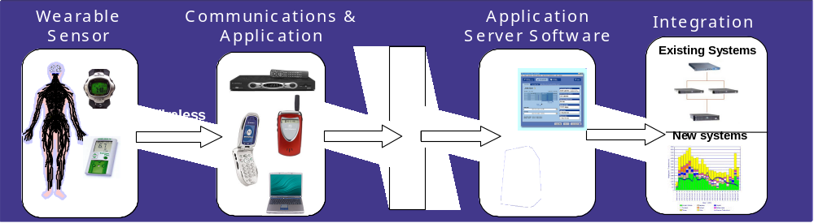

Figure 1. Schematic illustration of major segment of the TeleHealthcare value chain.

Motorola’s approach to envisioned solution can be divided into the following major areas:-
  - A suite of sensors, wearable & fixed, that monitor patients vital signs and other relevant parameters e.g. weight. All the sensors are wirelessly networked either on the patient’s body or through a PAN network to one or more centralized ‘routing’ application devices.
  - A ‘routing’ application device, which would typically be either a handheld wireless device or in home cable appliance. The application device can receive downloadable applications based upon patient’s condition and suite of sensors. The application collates and stores the relevant sensor information for subsequent transmission to the relevant health care service provider depending on the application and service. The application leverages the privacy and security capabilities in today’s devices as well as those being implemented in future generations of devices. It is envisaged that the transmission of medical data could either be continuous, at regular scheduled intervals, patient controlled or based upon preset alarm / out of bounds conditions set by the health care provider.
  - An application server and software would act as the central communications point for all patients supported by a healthcare service provider. The application server would manage the bi-directional communication between the patient and health care provider. The application server would interface with the healthcare providers existing medical and healthcare management systems. Ideally the application server would reside within the providers IT domain and would not store any personal patient information directly but would manage all patients by a unique identifier which would link to the healthcare providers existing database and management systems.
  - Systems Integration services would deliver the necessary application and systems level integration to connect the application server to the necessary network service providers and the healthcare providers information management systems. There will be additional opportunities to provide incremental application capabilities to both the application server and healthcare providers existing IT systems as adoption of the end to end system grows and the healthcare industry at large see new opportunities to modify its service deliver strategies.

Maintenance and upgrades to all of the major areas are seen as significant revenue opportunities. The ability to address a broader range of diseases, recovery and rehabilitation regimes in areas such as EMG and EEG as well as the expected evolution of sensors, networks etc. driving increased applications and service opportunities.

Motorola currently has pockets of activity distributed around business units and Labs looking at various aspects of the solution described above focusing in either one of these major areas or addressing an initial market. In order for Motorola to succeed in this market we need to bring all of these minor efforts together into one. A unified system level approach will enable Motorola to leverage the re-use of systems components as well as offer an array of solution approaches to meet the different patient and providers needs. We propose the consolidation of all of these fragmented efforts under a single Motorola TeleHealthcare accelerator business and drive to create a new product and market for Motorola.

The iDEN Tele-health Solutions team has the most extensive approach to all the major areas of the envisioned solution currently. Therefore we propose using their system architecture as the foundation into which we integrate other efforts and build from. This approach re-enforces their efforts to date and allows us to move expediently to capitalize on the market opportunity they are creating as well as bringing in other opportunities.

What Differentiates?
It is not just the functionality and technology Motorola can bring to the envisioned solution it is this combined with our proposed relationships and go to market strategy that differentiates our solution.

Business
Initial target market is Disease Management Companies and their Fortune 100 Self insured customer companies (We need to start with Motorola and use ourselves as a proof point & demonstrate the financial ROI). Rather than go directly into the medical treatment provider payer chain this approaches targets one of the parallel support services areas. This focus reduces the time to market, is an area that is underserved at this time and where there is opportunity based upon the significant cost & liabilities companies are facing for payment of medical services bills with both existing employees and retired employees with medical benefits. Telehealth programs to date have predominantly been trials or pilots by hospitals, few have evolved to the next phase of deployment it would appear due to initial large investment up front to deploy and the issues of having such approaches approved by the various billing and coding authorities.
Through this first market entry approach and demonstrating employees on employer’s self insured medical benefit’s programs significantly reduced their costs we will be able to leverage this into the other medical benefit programs employers offer as well as the providers of this service and Medicaid.
In all of these cases we will still need to obtain medical providers approval and FDA certification. Through our investment with GMP we intend to leverage their expertise and relationships with Doctors and hospital to obtain the necessary testing, and approvals.

Technology/Solution
It is not just the functionality and technology Motorola can bring to the envisioned solution it is this combined with our proposed relationships and go to market strategy that differentiates our solution.
By considering this as a complete end-to-end solution and leveraging our market position in handset and home cable markets, devices and infrastructure we have technology influence points that e can use to differentiate our solution. This will also enable our ability to drive and control the on going growth and expansion of the capabilities as well as the issue of support of such services.
Areas of technology differentiation or control are as follows:
- Ensure privacy & security of patient data, working with healthcare industry
- Wireless data transfer from sensor to hub (handheld, set top box, etc.) and network agnostic transfer to remote application server
- Secure and robust over the air application downloads to handheld devices and in home cable appliances for specific disease management regimes (the application is ‘prescribed’ for each disease type)
- Optimization of the solutions deployment and service costs by leveraging our expertise in wearables, secure wireless networks, wireless data communications, micro-miniaturization and system integration
- Scalability of solution architecture to cover broader range of diseases, and range of services (management, diagnosis, analysis)

Maintain Advantage
Initially, the key differentiator for Motorola compared to existing competitive solutions is the low cost, end-to-end wireless capabilities, the inclusion of patients existing wireless device and/or set to box and the solutions ease of use for the end customer. The competitive alternatives are typically focused on in-hospital needs with high price points or address only some segments of the wireless solution.

In order to ensure continued differentiation in this highly competitive market, Motorola will have to expand beyond the initial chronic disease markets to cover recovery and rehabilitation opportunities leveraging research in EMG and EEG sensor technologies. Develop IP in unique sensor technologies, transmission, and integration of sensors and wireless PAN networking for greater ease of use, and wearability. The development of new value added application software and leverage its Systems Integration experience, particularly in linkage with security and privacy requirements more broadly across the health care market while continuing to develop strategic partnerships.

- What is our current investment level? What are the contributing research projects (or external sources)?

Current investment level: Over 30 people in business units and Motorola labs are currently working on projects related to Health monitoring systems.

Current research projects in each area of the value chain are shown below.

 | Labs | Business Initiatives | External
Monitoring Sensors | • Bio Sensors (MATC)  • Microminiaturization  (MATC)  • PAN - Blue tooth, Zigbee  • 4.9 GHz (CRL) | • Sensors (SPS)  • Microminiaturization  (IESS, SPS)  • Wireless ICs (SPS)  • GPS (IESS) | • UIUC (MATC, CGISS)  • MIT (iDEN, GSG)
Communication Devices and Networks | • Home Gateway (BNRL) | • Portable Products  (PCS, iDEN,  CGISS)  • Set Top boxes  (BCS)
Application Server | • Multi-modal application servers  • Security | • Application download servers (PCS)
System Integration | • Extensive knowledge in SI but none specific of healthcare applications | • First Responder (CGISS)

5. What competencies do we have or need to acquire?

Competencies and gaps are identified in each of the four areas in the value chain

Area | Competencies | Gaps / Needs
Monitoring Sensors | •SPS & IESS have extensive experience in IC devices. SPS supplies medical sensors to health industry OEMs.  • Mot Labs – MATC & SSRL research in bio & environmental sensors and the application of MEMS technology for use in sensors & manufacturing  • Wireless networks is a strategic strength area for Motorola. Expertise in PAN, LAN and WAN. | •No proven wireless sensor technology specific to health target markets  • Supplier/partner relationships to obtain / lock-in breadth & variety of technologies and types of sensors required  • Active engagement in driving the development of wireless standards for health market.  •Application of new Nano technologies
Communication Devices and Networks | Strategic strength area for Motorola. Java & blue tooth enabled products already in market | Healthcare specific applications on portables.
Application Server | Expertise in some markets – Automotive, emergency services, dispatch. Developing knowledge in Bio (Health) & Environmental areas. | Limited knowledge in application specific areas of sensor data analysis in health care. GSG Welch-Allyn a learning experience.
System Integration | Systems level integration expertise within business units for many large scale applications | No direct experience in medical system integration.

6. What are the competing alternatives? What are the barriers to entry for us? For the competition?

The competition is strong but fragmented, with several dozen small companies focusing on different areas of the value chain. Hospital medical electronics' firms such as Medtronics, GE, HP, etc., focus on proprietary products with high prices. There is currently no in-home or mobile end-to-end wireless solution. Some key competitors are listed in the table below.

 | Competition
Monitoring Sensors | Medtronic, Omron Healthcare, Panasonic, Honeywell, several smaller companies such as Kivalo, Sensatex, etc.
Communication Devices and Networks | Nokia, Ericsson, March Networks, Several digital imaging companies Aethra, AMD Telemedicine, Apollo Telemedicine, etc.
Application Server | Health Hero, GE medical systems, Siemens Medical, Phillips Medical, etc.
System Integration | GE, Siemens Medical, Phillips Medical, American Telecare, Omron Healthcare, etc.

The Leadership Opportunity is in providing an end-to-end solution with low cost, in-home / mobile wireless data transfer between sensors & hub, network agnostic data transfer to app server and integration with existing systems.

The barriers to entry for Motorola include limited knowledge and experience in the healthcare field, lack of direct experience in healthcare specific applications and systems, minimal existing supplier and distributor relationships in healthcare field, etc. Many of these barriers are listed under technology and market gaps in the competencies section. Additional barriers as well as barriers for the competition, such as acceptance by major providers, are listed under market and technology risks.

7. What are the technology and market risks? Mitigation?

Market Risk | Mitigation
Telemedicine system acceptance by major providers | Implement phased strategy: self-insured corporations segment followed by insurers. Increasing functionality of devices and applications. Demonstrate savings at each phase
Open standards can result in lower barriers to entry for competition | Create barriers to entry though IP, partnerships and customer relationships
GMP – Exclusive rights to Motorola patents in defined fields | Continue iDEN legal efforts to resolve; Leverage GMP hospital relationships for doctor approval of devices.
Some competition is ahead of us in trials, early deployment of wired solutions and development of some areas of the value chain. | Offer distinctive wireless solutions in partnership with others

Technology Risk | Mitigation
Sensor data quality and life cycle | Develop and enhance data quality by leveraging experience in First Responder and Telemedicine applications
System security and Privacy | Leverage internal wireless security expertise to develop secure solutions
Limited internal knowledge of application specific data analysis | Develop expertise and explore partnerships with customers & medical solution suppliers

Appendix 1

IDEN’s Business Model Based upon Total US market Size with a 1% Penetration Rate

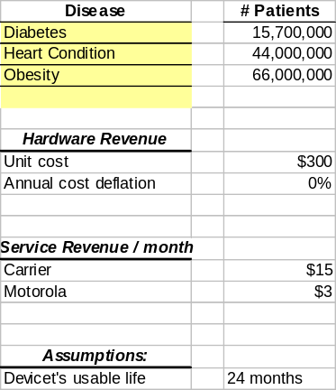

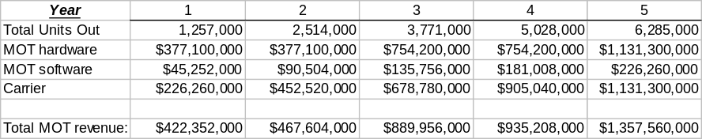

Disease Management Company market Opportunity – Focusing on Fortune 500 Self Insured Companies growing from installed based 3 Fortune 500 Companies in year 1.
